Universidad Europea de Madrid

Fluid Mechanics II

Homework 1

Due to October 7, 2020

**Problem 1**

Consider two immiscible fluids 1 and 2, flowing steadily down an inclined plane. The atmosphere exerts no shear stress on the surface and is at constant pressure. Determine the laminar velocity distribution in the tow layer.

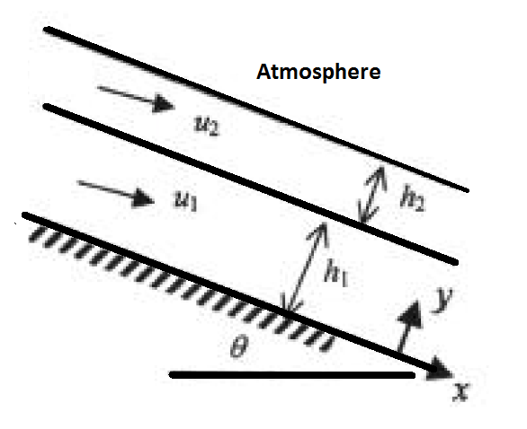

**Problem 2**

Two infinite plates are 2h apart, the lower plate is fixed and the upper plate moves at speed U. The pressure is assumed constant. The upper plate is insulated and at the lower plate, the heat transfer is due to convention. These boundary conditions are independent of x and z (infinite plates), hence it follows that u=u(y) and T=T(y). Find the velocity and temperature distribution of the fluid. Plot the velocity and temperature profiles. From the plots, determine the velocity and temperature at y=0, y= h/2, y=-h/2, y=h and y=-h. The working fluid is SAE oil at 20°C. U= 0,5m/s and h=1mm.

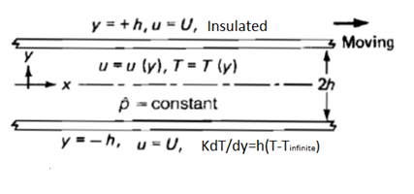

Governing equations:



Where φ is :



**Problem 3**

Air at 20°C and 1atm is at rest between two fixed parallel plates 5mm apart. At time t=0, the lower plate suddenly begins to move tangentially at 20cm/s. Compute the air velocity in the center between plates after 2s, 4s and 2minutes.